**IT24103927**

**Hettiarachchi H.S.A**

**Probability and Statistics - IT2120**

**Lab Sheet 5**

**1.**

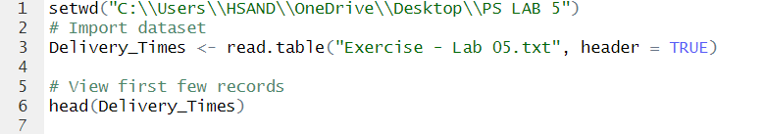

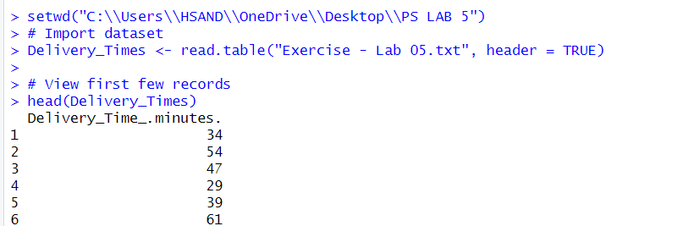

**2.**

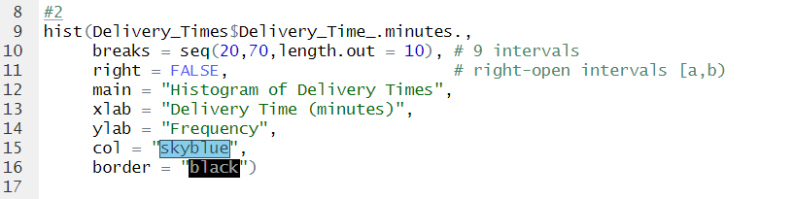

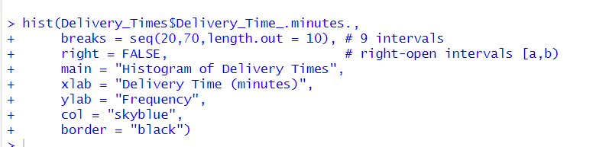

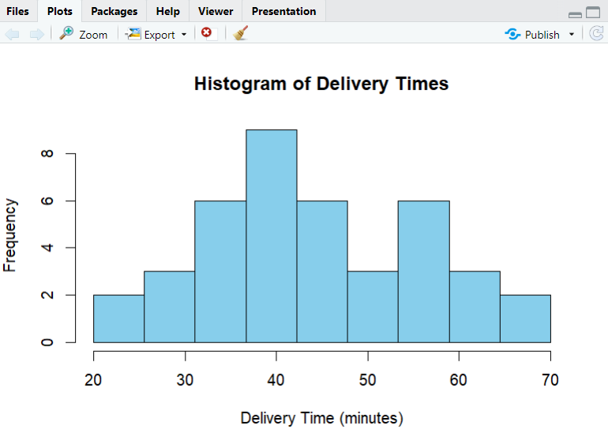

**3.**

The distribution of delivery times is approximately symmetric and bell-shaped, indicating it follows a near-normal distribution with most delivery times clustered around 40 minutes.

**4.**

